Data model as heard is

🡪Pictorial representation of tables

🡪relationship between tables

🡪Easily understood

3 Stages of data model

1.Conceptual Data model

2.Logical Data model

3.Physical data model

**Conceptual data model**

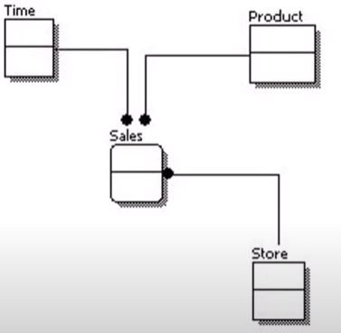

Conceptual Data model is rough idea which does not require any documentation/tools to create. It can be updated anytime as rough idea mainly used on piece of paper or white dashboard.

🡪Easily understood by user as well as tech users

🡪Only entities r visible and abstract relationship

**Logical data model**

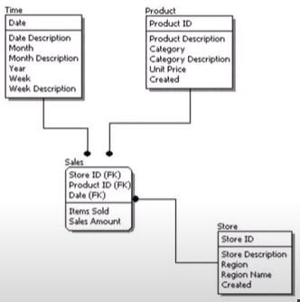

🡪Contain more info than Conceptual

🡪Attributes of each entities are present in logical schema.

🡪Key and non-key attributes

🡪User friendly attributes name

🡪tools used like erWin or powerdesigner. Automatically converted to physical data schema also using these tools.

Physical data model

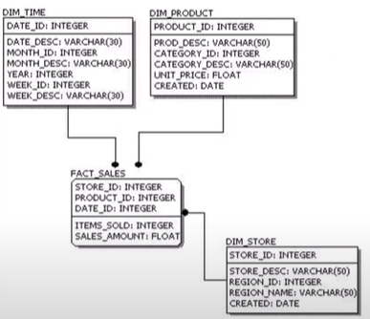

🡪Configuring about dimension/facts tables.

🡪Size of table is defined by size of each attributes and which type.

🡪Complex for users

🡪Attributes named as columns

🡪Db compatible alias name along with columns name also including index triggers and other dbms objects.